Student Information System

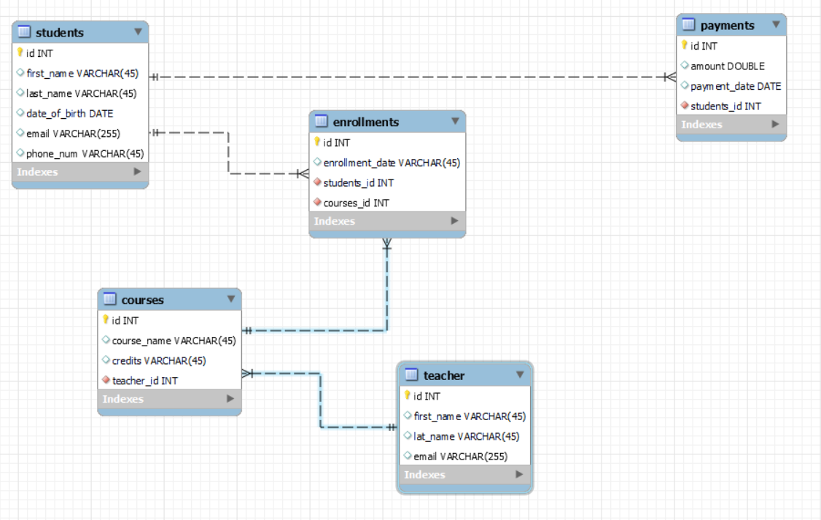

-- -----------------------------------------------------

-- Schema student_information_system

-- -----------------------------------------------------

-- -----------------------------------------------------

-- Schema student_information_system

-- -----------------------------------------------------

CREATE SCHEMA IF NOT EXISTS `student_information_system` DEFAULT CHARACTER SET utf8 ;

USE `student_information_system` ;

-- -----------------------------------------------------

-- Table `student_information_system`.`students`

-- -----------------------------------------------------

CREATE TABLE IF NOT EXISTS `student_information_system`.`students` (

`id` INT NOT NULL AUTO_INCREMENT,

`first_name` VARCHAR(45) NULL,

`last_name` VARCHAR(45) NULL,

`date_of_birth` DATE NULL,

`email` VARCHAR(255) NULL,

`phone_num` VARCHAR(45) NULL,

PRIMARY KEY (`id`))

ENGINE = InnoDB;

-- -----------------------------------------------------

-- Table `student_information_system`.`teacher`

-- -----------------------------------------------------

CREATE TABLE IF NOT EXISTS `student_information_system`.`teacher` (

`id` INT NOT NULL AUTO_INCREMENT,

`first_name` VARCHAR(45) NULL,

`lat_name` VARCHAR(45) NULL,

`email` VARCHAR(255) NULL,

PRIMARY KEY (`id`))

ENGINE = InnoDB;

-- -----------------------------------------------------

-- Table `student_information_system`.`courses`

-- -----------------------------------------------------

CREATE TABLE IF NOT EXISTS `student_information_system`.`courses` (

`id` INT NOT NULL AUTO_INCREMENT,

`course_name` VARCHAR(45) NULL,

`credits` VARCHAR(45) NULL,

`teacher_id` INT NOT NULL,

PRIMARY KEY (`id`),

INDEX `fk_courses_teacher_idx` (`teacher_id` ASC) ,

CONSTRAINT `fk_courses_teacher`

FOREIGN KEY (`teacher_id`)

REFERENCES `student_information_system`.`teacher` (`id`)

ON DELETE NO ACTION

ON UPDATE NO ACTION)

ENGINE = InnoDB;

-- -----------------------------------------------------

-- Table `student_information_system`.`enrollments`

-- -----------------------------------------------------

CREATE TABLE IF NOT EXISTS `student_information_system`.`enrollments` (

`id` INT NOT NULL AUTO_INCREMENT,

`enrollment_date` VARCHAR(45) NULL,

`students_id` INT NOT NULL,

`courses_id` INT NOT NULL,

PRIMARY KEY (`id`),

INDEX `fk_enrollments_students1_idx` (`students_id` ASC) ,

INDEX `fk_enrollments_courses1_idx` (`courses_id` ASC) ,

CONSTRAINT `fk_enrollments_students1`

FOREIGN KEY (`students_id`)

REFERENCES `student_information_system`.`students` (`id`)

ON DELETE NO ACTION

ON UPDATE NO ACTION,

CONSTRAINT `fk_enrollments_courses1`

FOREIGN KEY (`courses_id`)

REFERENCES `student_information_system`.`courses` (`id`)

ON DELETE NO ACTION

ON UPDATE NO ACTION)

ENGINE = InnoDB;

-- -----------------------------------------------------

-- Table `student_information_system`.`payments`

-- -----------------------------------------------------

CREATE TABLE IF NOT EXISTS `student_information_system`.`payments` (

`id` INT NOT NULL AUTO_INCREMENT,

`amount` DOUBLE NULL,

`payment_date` DATE NULL,

`students_id` INT NOT NULL,

PRIMARY KEY (`id`),

INDEX `fk_payments_students1_idx` (`students_id` ASC) ,

CONSTRAINT `fk_payments_students1`

FOREIGN KEY (`students_id`)

REFERENCES `student_information_system`.`students` (`id`)

ON DELETE NO ACTION

ON UPDATE NO ACTION)

ENGINE = InnoDB;

--Insertions

insert into students(first_name,last_name,date_of_birth,email,phone_num) values

('nivetha','R','12.11.2002','nive@gmail.com','98765'),

('nirupama','S','10.1.2002','niru@gmail.com','12345'),

('hari','A','7.8.2002','hari@gmail.com','10002'),

('anu','S','3.12.2002','anu@gmail.com','13579'),

('nithi','B','25.5.2003','nithi@gmail.com','24680'),

('sangeetha','S','15.11.2002','sangee@gmail.com','50000');

select * from students;

+----+------------+-----------+---------------+----------------------+------------+

| id | first_name | last_name | date_of_birth | email | phone_num |

+----+------------+-----------+---------------+----------------------+------------+

| 1 | nivetha | R | 2012-11-20 | nive@gmail.com | 98765 |

| 2 | nirupama | S | 2010-01-20 | niru@gmail.com | 12345 |

| 3 | hari | A | 2007-08-20 | hari@gmail.com | 10002 |

| 4 | anu | S | 2003-12-20 | anu@gmail.com | 13579 |

| 5 | nithi | B | 2025-05-20 | nithi@gmail.com | 24680 |

| 6 | sangeetha | S | 2015-11-20 | sangee@gmail.com | 50000 |

insert into teacher(first_name,lat_name,email) values

('jayanthi','S','jainthi@gmail.com'),

('shanthi','M','shanthi@gmail.com'),

('janai','R','janani@gmail.com'),

('sajeetha','B','sajee@gmail.com'),

('priya','E','priya@gmail.com');

Select * from teacher;

+----+------------+----------+-------------------+

| id | first_name | lat_name | email |

+----+------------+----------+-------------------+

| 1 | jayanthi | S | jainthi@gmail.com |

| 2 | shanthi | M | shanthi@gmail.com |

| 3 | janai | R | janani@gmail.com |

| 4 | sajeetha | B | sajee@gmail.com |

| 5 | priya | E | priya@gmail.com |

+----+------------+----------+-------------------+

insert into courses(course_name,credits,teacher_id) values

('java','A','1'),

('python','B','2'),

('c#','C','3'),

('jva script','D','4'),

('SQL','E','5');

Select * from courses;

+----+-------------+---------+------------+

| id | course_name | credits | teacher_id |

+----+-------------+---------+------------+

| 1 | java | A | 1 |

| 2 | python | B | 2 |

| 3 | c# | C | 3 |

| 4 | jva script | D | 4 |

| 5 | SQL | E | 5 |

+----+-------------+---------+------------+

INSERT INTO enrollments(enrollment_date, students_id, courses_id)

VALUES

('2024-01-01', 1, 1),

('2024-01-02', 2, 2),

('2024-01-03', 3, 3),

('2024-01-04', 4, 4),

('2024-01-05', 5, 5);

Select * from enrollments;

+----+-----------------+-------------+------------+

| id | enrollment_date | students_id | courses_id |

+----+-----------------+-------------+------------+

| 1 | 2024-01-01 | 1 | 1 |

| 2 | 2024-01-02 | 2 | 2 |

| 3 | 2024-01-03 | 3 | 3 |

| 4 | 2024-01-04 | 4 | 4 |

| 5 | 2024-01-05 | 5 | 5 |

+----+-----------------+-------------+------------+

INSERT INTO payments(id, amount, payment_date, students_id)

VALUES

(1, 1000, '2024-01-01', 1),

(2, 1500, '2024-01-02', 2),

(3, 800, '2024-01-03', 3),

(4, 1200, '2024-01-04', 4),

(5, 1600, '2024-01-05', 5);

Select * from payments;

+----+--------+--------------+-------------+

| id | amount | payment_date | students_id |

+----+--------+--------------+-------------+

| 1 | 1000 | 2024-01-01 | 1 |

| 2 | 1500 | 2024-01-02 | 2 |

| 3 | 800 | 2024-01-03 | 3 |

| 4 | 1200 | 2024-01-04 | 4 |

| 5 | 1600 | 2024-01-05 | 5 |

+----+--------+--------------+-------------+

Tasks 2 - Select, Where, Between, AND, LIKE

1. Write an SQL query to insert a new student into the "Students" table with the following details:

a. First Name: John

b. Last Name: Doe

c. Date of Birth: 1995-08-15

d. Email: john.doe@example.com

e. Phone Number: 123456789

insert into students (first_name, last_name, date_of_birth, email, phone_num)

values ('john', 'doe', '1995-08-15', 'john.doe@example.com', '1234567890');

+----+------------+-----------+---------------+----------------------+------------+

| id | first_name | last_name | date_of_birth | email | phone_num |

+----+------------+-----------+---------------+----------------------+------------+

| 1 | nivetha | r | 2012-11-20 | nive@gmail.com | 98765 |

| 2 | nirupama | s | 2010-01-20 | niru@gmail.com | 12345 |

| 3 | hari | a | 2007-08-20 | hari@gmail.com | 10002 |

| 4 | anu | s | 2003-12-20 | anu@gmail.com | 13579 |

| 5 | nithi | b | 2025-05-20 | nithi@gmail.com | 24680 |

| 6 | sangeetha | s | 2015-11-20 | sangee@gmail.com | 50000 |

| 7 | john | doe | 1995-08-15 | john.doe@example.com | 1234567890 |

+----+------------+-----------+---------------+----------------------+------------+

2. write an sql query to enroll a student in a course. choose an existing student and course and insert a record into the "enrollments" table with the enrollment date.

insert into enrollments (enrollment_date, students_id, courses_id)

values ('2024-03-06', 3, 3);

select * from enrollments;

+----+-----------------+-------------+------------+

| id | enrollment_date | students_id | courses_id |

+----+-----------------+-------------+------------+

| 1 | 2024-01-01 | 1 | 1 |

| 2 | 2024-01-02 | 2 | 2 |

| 3 | 2024-01-03 | 3 | 3 |

| 4 | 2024-01-04 | 4 | 4 |

| 5 | 2024-01-05 | 5 | 5 |

| 6 | 2024-03-06 | 3 | 3 |

3. update the email address of a specific teacher in the "teacher" table. choose any teacher and modify their email address.

update teacher

set email = 'teacher@gmail.com'

where id = 4;

select * from teacher;

+----+------------+----------+-------------------+

| id | first_name | lat_name | email |

+----+------------+----------+-------------------+

| 1 | jayanthi | s | jainthi@gmail.com |

| 2 | shanthi | m | shanthi@gmail.com |

| 3 | janai | r | janani@gmail.com |

| 4 | sajeetha | b | teacher@gmail.com |

| 5 | priya | e | priya@gmail.com |

+----+------------+----------+-------------------+

4. write an sql query to delete a specific enrollment record from the "enrollments" table. select an enrollment record based on the student and course.

delete from enrollments

where students_id = 1 and courses_id = 1;

+----+-----------------+-------------+------------+

| id | enrollment_date | students_id | courses_id |

+----+-----------------+-------------+------------+

| 2 | 2024-01-02 | 2 | 2 |

| 3 | 2024-01-03 | 3 | 3 |

| 4 | 2024-01-04 | 4 | 4 |

| 5 | 2024-01-05 | 5 | 5 |

| 6 | 2024-03-06 | 3 | 3 |

+------------------+---------------+-----+---------------+

5. update the "courses" table to assign a specific teacher to a course. choose any course and teacher from the respective tables.

update courses

set teacher_id = 1

where id = 2;

+----+-------------+---------+------------+

| id | course_name | credits | teacher_id |

+----+-------------+---------+------------+

| 1 | java | a | 1 |

| 2 | python | b | 1 |

| 3 | c# | c | 3 |

| 4 | jva script | d | 4 |

| 5 | sql | e | 5 |

+----+-------------+---------+------------+

6. delete a specific student from the "students" table and remove all their enrollment records from the "enrollments" table. be sure to maintain referential integrity.

set student_id = 1;

delete from enrollments where students_id = 1;

delete from students where students_id=1;

+----+-----------------+-------------+------------+

| id | enrollment_date | students_id | courses_id |

+----+-----------------+-------------+------------+

| 4 | 2024-01-04 | 4 | 4 |

| 5 | 2024-01-05 | 5 | 5 |

+----+-----------------+-------------+------------+

+----+------------+-----------+---------------+----------------------+------------+

| id | first_name | last_name | date_of_birth | email | phone_num |

+----+------------+-----------+---------------+----------------------+------------+

| 2 | nirupama | s | 2010-01-20 | niru@gmail.com | 12345 |

| 3 | hari | a | 2007-08-20 | hari@gmail.com | 10002 |

| 4 | anu | s | 2003-12-20 | anu@gmail.com | 13579 |

| 5 | nithi | b | 2025-05-20 | nithi@gmail.com | 24680 |

| 6 | sangeetha | s | 2015-11-20 | sangee@gmail.com | 50000 |

| 7 | john | doe | 1995-08-15 | john.doe@example.com | 1234567890 |

+----+------------+-----------+---------------+----------------------+------------+

7. update the payment amount for a specific payment record in the "payments" table. choose any payment record and modify the payment amount.

update payments

set amount = 2000

where id = 1;

+----+--------+--------------+-------------+

| id | amount | payment_date | students_id |

+----+--------+--------------+-------------+

| 1 | 2000 | 2024-01-01 | 1 |

| 2 | 1500 | 2024-01-02 | 2 |

| 3 | 800 | 2024-01-03 | 3 |

| 4 | 1200 | 2024-01-04 | 4 |

| 5 | 1600 | 2024-01-05 | 5 |

+----+--------+--------------+-------------+

task 3 - aggregate functions, having, order by, groupby and joins:

1. write an sql query to calculate the total payments made by a specific student. you will need to join the "payments" table with the "students" table based on the student's id.

select s.first_name, s.last_name, sum(p.amount) as total_payments

from students s

join payments p on s.id = p.students_id

where s.id = 3;

+------------+-----------+----------------+

| first_name | last_name | total_payments |

+------------+-----------+----------------+

| hari | a | 800 |

+------------+-----------+----------------+

1. write an sql query to retrieve a list of courses along with the count of students enrolled in each course. use a join operation between the "courses" table and the "enrollments" table.

select c.course_name, count(e.students_id) as student_count

from courses c

left join enrollments e on c.id = e.courses_id

group by c.id;

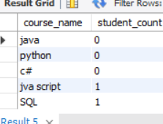

1. write an sql query to find the names of students who have not enrolled in any course. use a left join between the "students" table and the "enrollments" table to identify students without enrollments.

select s.first_name, s.last_name

from students s

left join enrollments e on s.id = e.students_id

where e.students_id is null;

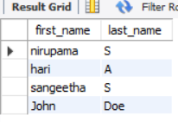

1. write an sql query to retrieve the first name, last name of students, and the names of the courses they are enrolled in. use join operations between the "students" table and the "enrollments" and "courses" tables

select s.first_name, s.last_name, c.course_name

from students s

join enrollments e on s.id = e.students_id

join courses c on e.courses_id = c.id;

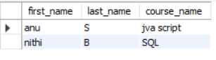

1. create a query to list the names of teachers and the courses they are assigned to. join the "teacher" table with the "courses" table.

select t.first_name, t.lat_name, c.course_name

from teacher t

join courses c on t.id = c.teacher_id

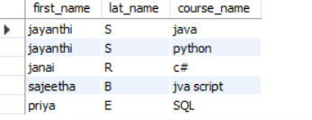

1. retrieve a list of students and their enrollment dates for a specific course. you'll need to join the "students" table with the "enrollments" and "courses" table

select s.first_name, s.last_name, e.enrollment_date

from students s

join enrollments e on s.id = e.students_id

join courses c on e.courses_id = c.id

where c.course_name = 'sql';

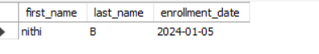

1. find the names of students who have not made any payments. use a left join between the "students" table and the "payments" table and filter for students with null payment records

select s.first_name, s.last_name

from students s

left join payments p on s.id = p.students_id

where p.students_id is null;

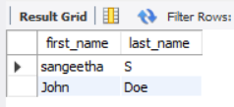

1. write a query to identify courses that have no enrollments. you'll need to use a left join between the "courses" table and the "enrollments" table and filter for courses with null enrollment records

select c.course_name

from courses c

left join enrollments e on c.id = e.courses_id

where e.courses_id is null;

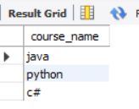

9. identify students who are enrolled in more than one course. use a self-join on the "enrollments" table to find students with multiple enrollment records.

select s.first_name, s.last_name, count(e.courses_id) as course_count

from students s

join enrollments e on s.id = e.students_id

group by s.id

having count(e.courses_id) > 1;



1. find teachers who are not assigned to any courses. use a left join between the "teacher" table and the "courses" table and filter for teachers with null course assignments.

select t.first_name, t.lat_name

from teacher t

left join courses c on t.id = c.teacher_id

where c.teacher_id is null;

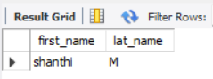

task 4 - subquery and its type:

1. write an sql query to calculate the average number of students enrolled in each course. use aggregate functions and subqueries to achieve this.

select avg(student_count) as avg_students_per_course

from (

select count(*) as student_count

from enrollments

group by courses_id

) as course_counts;



1. identify the student(s) who made the highest payment. use a subquery to find the maximum payment amount and then retrieve the student(s) associated with that amount

select s.first_name, s.last_name

from students s

where s.id in (select students_id from payments where amount = (select max(amount) from payments));

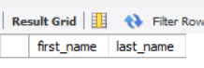

1. retrieve a list of courses with the highest number of enrollments. use subqueries to find the course(s) with the maximum enrollment count

select c.course_name, count(e.students_id) as enrollment_count

from courses c

left join enrollments e on c.id = e.courses_id

group by c.id

having count(e.students_id) = (select max(enrollment_count) from (select count(*) as enrollment_count from enrollments group by courses_id) as counts);

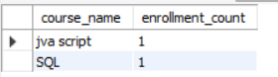

1. calculate the total payments made to courses taught by each teacher. use subqueries to sum payments for each teacher's courses

select t.first_name, t.lat_name, sum(p.amount) as total_payments

from teacher t

join courses c on t.id = c.teacher_id

join enrollments e on c.id = e.courses_id

join payments p on e.students_id = p.students_id

group by t.id;

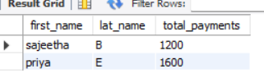

1. identify students who are enrolled in all available courses. use subqueries to compare a student's enrollments with the total number of courses.

select s.first_name, s.last_name

from students s

where (select count(distinct courses_id) from enrollments where students_id = s.id) = (select count(*) from courses);



1. retrieve the names of teachers who have not been assigned to any courses. use subqueries to find teachers with no course assignments

select t.first_name, t.last_name

from teacher t

where t.id not in (select distinct teacher_id from courses);

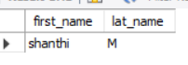

1. calculate the average age of all students. use subqueries to calculate the age of each student based on their date of birth.

select avg(datediff(curdate(), date_of_birth) / 365) as average_age

from students;

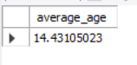

1. identify courses with no enrollments. use subqueries to find courses without enrollment records.

select c.course_name

from courses c

where c.id not in (select distinct courses_id from enrollments);

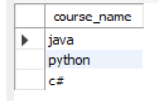

1. calculate the total payments made by each student for each course they are enrolled in. use subqueries and aggregate functions to sum payments.

select s.first_name, s.last_name, c.course_name, sum(p.amount) as total_payments

from students s

join enrollments e on s.id = e.students_id

join courses c on e.courses_id = c.id

join payments p on e.students_id = p.students_id

group by s.id, c.id;

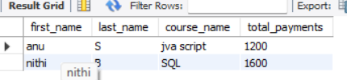

1. identify students who have made more than one payment. use subqueries and aggregate functions to count payments per student and filter for those with counts greater than one.

select s.first_name, s.last_name

from students s

where s.id in (select students_id from payments group by students_id having count(*) > 1);



1. write an sql query to calculate the total payments made by each student. join the "students" table with the "payments" table and use group by to calculate the sum of payments for each student.

select s.first_name, s.last_name, sum(p.amount) as total_payments

from students s

join payments p on s.id = p.students_id

group by s.id;

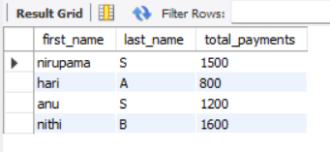

1. retrieve a list of course names along with the count of students enrolled in each course. use join operations between the "courses" table and the "enrollments" table and group by to count enrollments.

select c.course_name, (select count(*) from enrollments where courses_id = c.id) as student_count

from courses c;

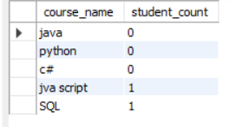

1. calculate the average payment amount made by students. use join operations between the "students" table and the "payments" table and group by to calculate the average

select avg(amount) as average_payment_amount

from payments;

